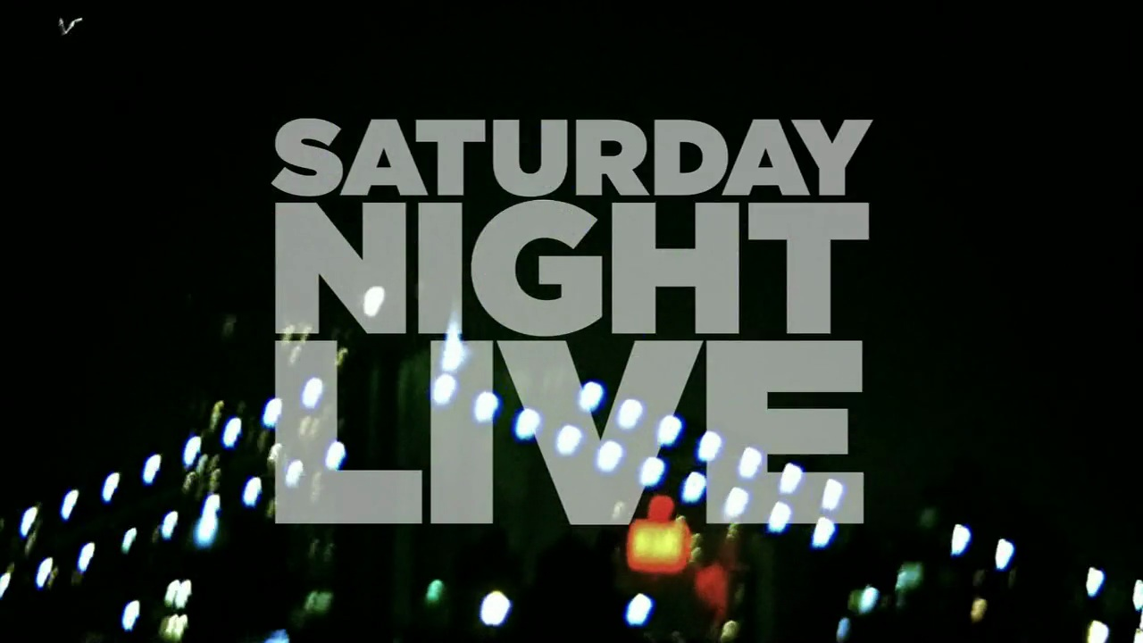
Parody Video Project
Video Tech
Boulan Park Middle School

A parody (pron.: /ˈpærədi/; also called spoof, send-up or lampoon), in current use, is an imitative work created to mock, comment on or trivialise^{[citation needed]} an original work, its subject, author, style, or some other target, by means of satiric or ironic imitation.

Your three to five minute video must reflect sound preparation and planning (including a storyboard). In addition, each video should demonstrate a strong understanding of the entire production process. This should be a fun project, remember to use as many of the options available in iMovie as possible.

Rubric
Content – 20 points
- Talent effectively conveyed the mood of the production
- Director eliminated irrelevant material
- Focus maintained, viewer can follow the plot

Editing
- Editing is consistent and flows
- Audio levels are consistent and effectively mixed
- Timing of edits is appropriate and in sync with audio
- Smooth transitions
- Camera lens focused throughout production
- Shots well framed
- Title/Effects appropriately used throughout edit
- A variety of shots, angles and filming techniques used
- Effective and appropriate use of chroma key (green screen)

Standard
- Intro/Credits
- Within required time limit
- Professional appearance
- Storyboard accurately reflects submitted video
- Submitted on or before deadline

Overall Product
- Wow factor
- Television worthy production
- Flow/pacing keeps viewer engaged

